- Python
  - set: unordered collection of unique elements.
  - array: data structure that holds a fixed-size sequence of elements of the same type
  - tuple: ordered, immutable collection of elements.
  - list in Python is an ordered, mutable collection of elements that can be of different types.
  - dictionary in Python is an unordered collection of key-value pairs, where each key is unique.
- Eigenvectors
- my_set = {1, 2, 3}
- my_dict = { "name": "Alice", "age": 30, "city": "New York" }
- my_list = [1, 2, 3, 4, 5]
- my_tuple = (1, 2, 3)

- sine function attribute
  - periodic, trigonometric, cycle infinitely The sine function is periodic. This means that the values oscillate between two values, in this case, positive one and negative one, at regular intervals (or periods). This also proves to be a continuous function. Sine is a trigonometric function, not polynomial. Sine waves cycle infinitely.

- dropout
  - model.add(Dropout(0.5))

- slope intercept The equation y=mx+by = mx + by=mx+b represents a straight line in a two-dimensional Cartesian coordinate system, where yyy is the dependent variable and xxx is the independent variable. Here, mmm denotes the slope of the line, which determines its steepness and direction, while bbb represents the y-intercept, the point where the line crosses the y-axis. This linear equation is foundational in algebra and is used to model linear relationships between variables.
- can act as axes within a data sample in order to measure loss. Eigenvectors = principal components. 4.50000000 (largest one\)
- kernel are filters in a CNN (3x3). function that adds dimensions to a support vector machine

- Nyquist frequency: The Nyquist Frequency is one-half of the sampling rate. It is measured in samples per second and specified in Hz/kHz/MHz/GHz. The Nyquist-Shannon sampling theorem demonstrates that this range is from zero to 𝑆𝑓 /2 where 𝑆𝑓 is the sampling frequency. This value is known as the Nyquist frequency.
  - sample rate = 86,400 ; Nyquist frequency = 43,200
  - sampling rate 300 Nyquist frequency = 150kHz

- high bias = very consistent results, difficulty learning

- creating decision trees with many features risks overfitting; = classification algorithm that can process large dataset while keeping computation costs low; drawback is no notification sent to user when a classification fails A Decision Tree is unable to tell a user if it cannot classify something. An interesting benefit of a Decision Tree is that classification will always take some finite number of steps. The bottom nodes will have a Gini value of 0.

AUCROC is based on decision thresholds

Mean squared error: as the error gets greater the slope of the loss function becomes greater at that point.

In CNNs kernels are applied to the input data

bottleneck layer of autoencoder = latent space

Robust scaling uses the median and the interquartile range to make itself more resistant to outliers

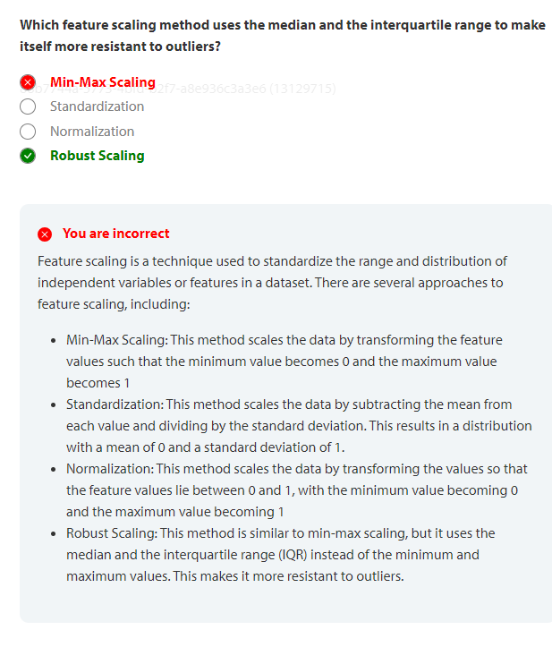
Huber loss combines MSE and MAE. effective when a network is prevented from converging due to the difference in the output and the input becoming very large.

categorical cross-entropy is a loss function calculated as the sum of all the logarithms of all the softmax activations for the the predictions

ID fields are a standard NoSQL feature

MongoDB console runs show dbs

email spam filters are based on Bayes Theorem

4.50000000 (largest one\)

inner join in SQL returns columns from both tables

trees generated from randomly selected features is the output of Bagging

P (Y|X) = probability and Y given X

Confusion matrix: TP 20, FN 5, FN 10, TN 15 = .67

variance = sum of the squared differences of all values of x and the mean -- divide the value by n-1

categorization = knowing whether an event is normal or abnormal

Confusion matrix = help calculate the models precision

learning= process when a computer uses a regression algorithm to revise the coefficients used in a function to minimize loss

Derivative = how the value of one term in a function changes relative to another

order + highest exponent

a kernel must be installed to use Ruby in Jupyter

standard deviation translates the variance in the same scale as a data set

flat = iterable reference that allows an array to be views as a 1 d structure

Valid convolution results in a reduction in the overall size of the matrix in a CNN = no padding

autoencoder = network trained to match the output to the input data
Kernel functions:
- Radial Basis Function is related to the Gaussian kernel. used to create complex, multidimensional decision boundaries
- Gaussian kernel is a specific example of the more general Radial Basis Function

activation function: activation function of a node in an artificial neural network is a function that calculates the output of the node based on its individual inputs and their weights. Nontrivial problems can be solved using only a few nodes
Leaky Rectified Linear Unit (Leaky ReLU) is an activation function in neural networks that allows a small gradient for negative values, instead of being completely zero. This helps to reduce the risk of overfitting and is especially useful in tasks that may experience sparse gradients.

loss functions
- root mean squared error is useful when the loss vanishes
- Binary cross entropy is a loss function commonly used in classification models

db.giacmodels.find({},{“name”:1,_v:1}) = projection The MongoDB db.collections.find method allows for projection parameters. The names of the fields to include are contained in curly brackets. Each of these is listed as a key, such as __v (for version). A value of one indicates to return this value in the resulting projection.

soft boundary allows for acceptable misclassification. allows for some margin of values to be misclassified. This allows for additional circumstances to be considered rather than limiting classification to a very specific threshold. A real world example for this would be failed user logon events. Not all repeat failed logon events are automatically "malicious" in nature.

Bayes' Theorem is a way to determine conditional probability, ie 𝑃(𝑌|𝑋)= 𝑃(𝑋|𝑌) × 𝑃(𝑌) / 𝑃(𝑋) = .08 x .15 / .06 = .20 (or 20%). (rootkits )

database= A collection of tables When we take multiple tables and put them together (think of an Excel workbook) we now have a database. Therefore, a database can be defined as a collection of tables, each of which contains rows made up of columns or fields that contain information.

- define objects with unknown field
  - A safe way to define fields within a class, especially if the data is unknown, is to use StringField() as the data type. It can store any arbitrary length string. Other options such as IntField() and LongField() are used to store specific integer data types. MultiLineStringField is a GeoJSON field that stores a list of geographic coordinates.

What does this graph show? Fourier series
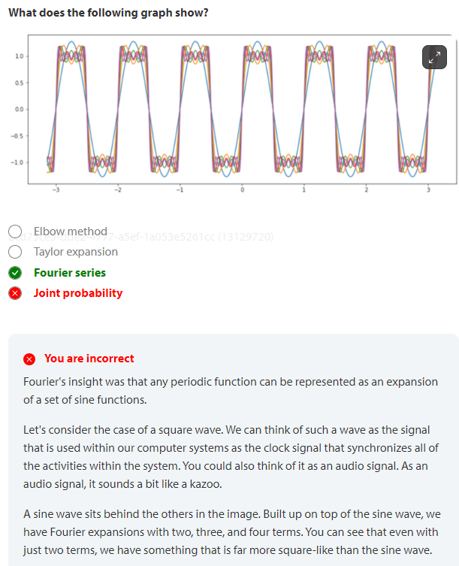

- What approach to represented data minimizes the loss function when performing deep learning?
  - Gradient Descent is one of the most common approaches used today to minimize the value of the loss function when performing deep learning. While you will find other optimization functions with a variety of names, most of them are just different approaches to Gradient Descent.

stringfield
gini coefficient .5

